LAB REPORT

**By: Ali Mubeen #210201037**

**In this code we are calculating a the inverse of a user input 2x2 matrix. In order to find the inverse of a matrix, the following steps are involved:**

* **Firstly, we have to find the determinant of the matrix i.e by multiplying the diagonals and subtracting then.**
* **Then we find the adjoint of the matrix.**
* **And lastly, we divide the adjoint by the determinant of the matrix.**

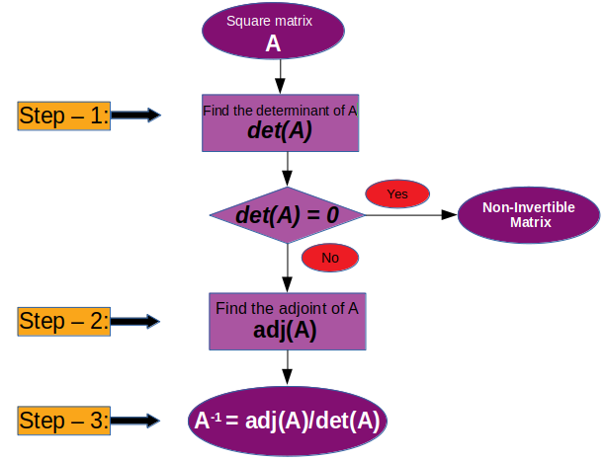**This is the thought process used in the given code.**

**Here are the screenshots of the constructed code:**

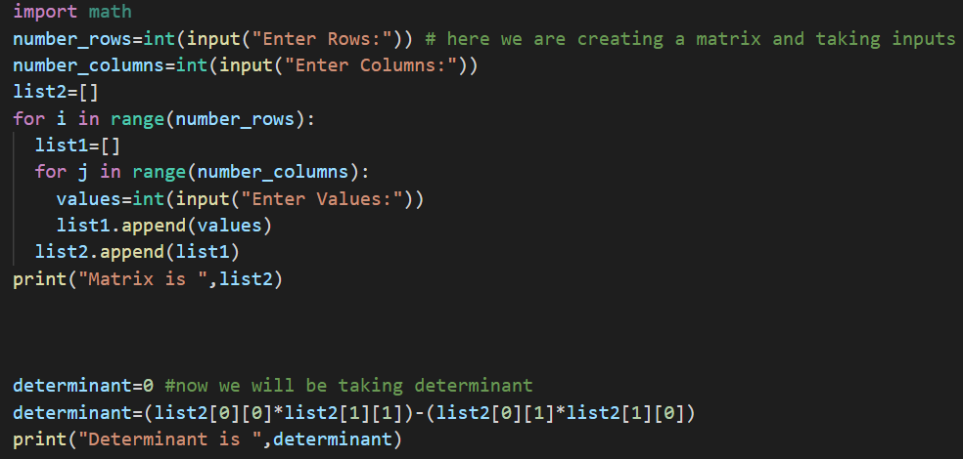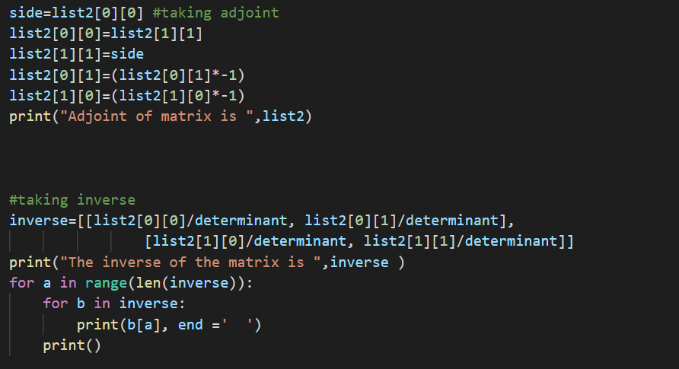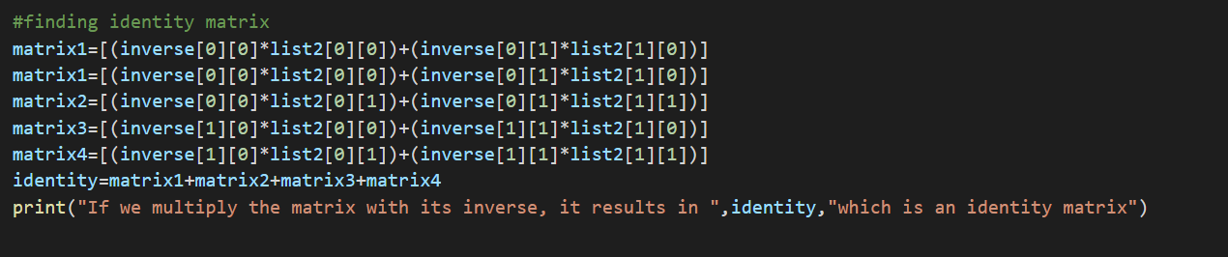

**Here is the result:**

